Database Systems Lab # 9
By:
Abubakar Shahid
21L-5845
BSE-4B2

Task-1
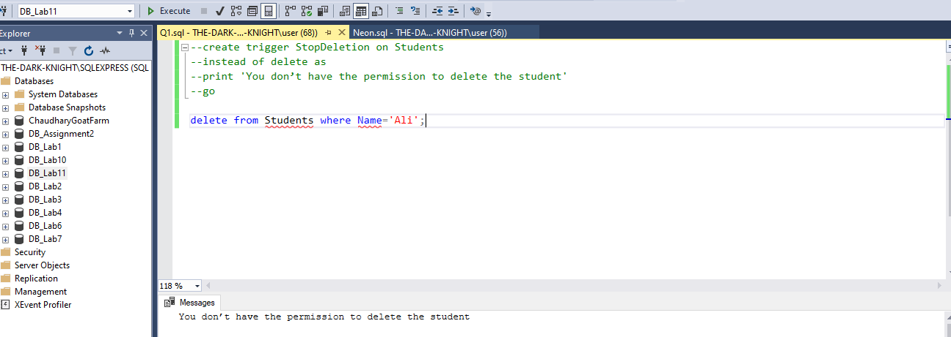

Task-2
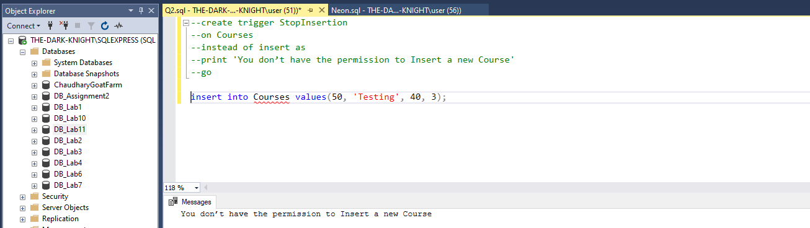

Task-3
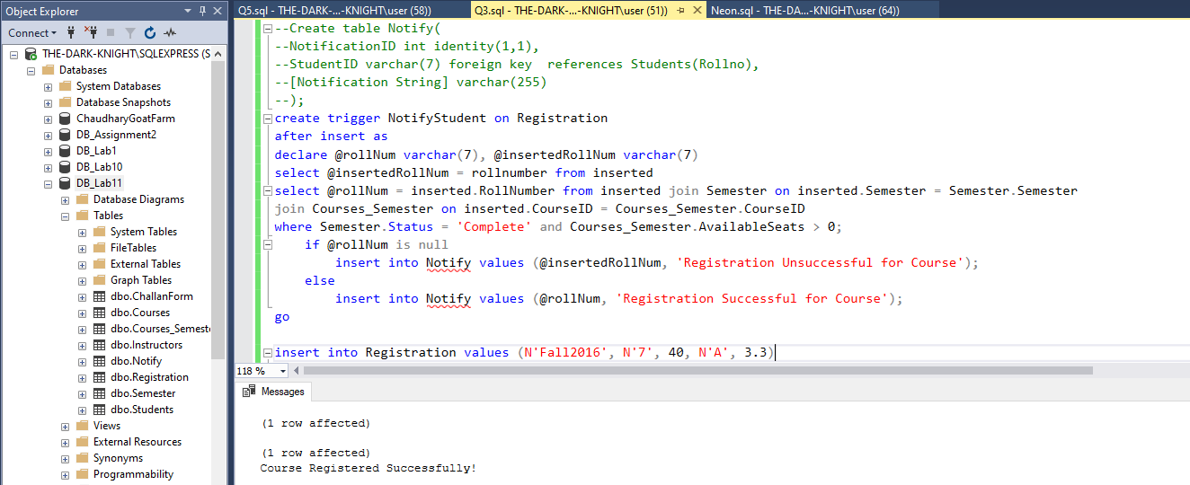

Task-4
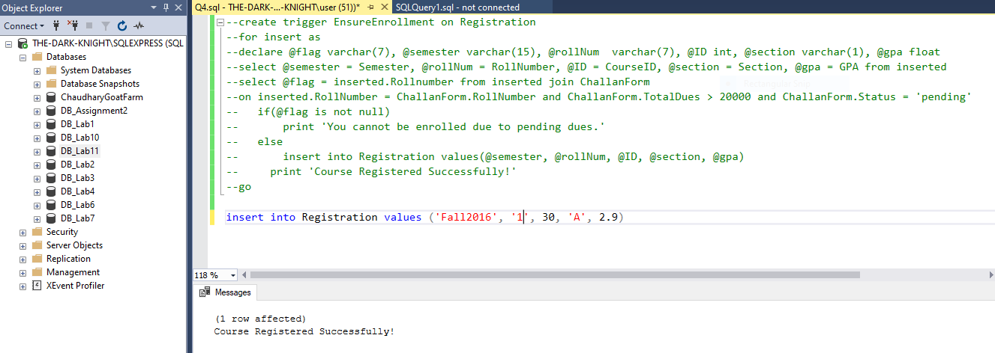

Task-5
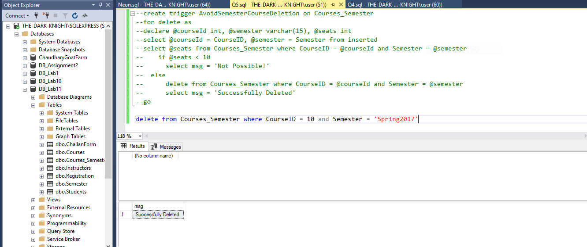

Task-6
